**Lab Submission_2**

**DB Lab**

**Submitted by: Sharifullah Danish**

**2:** Display the data of employees

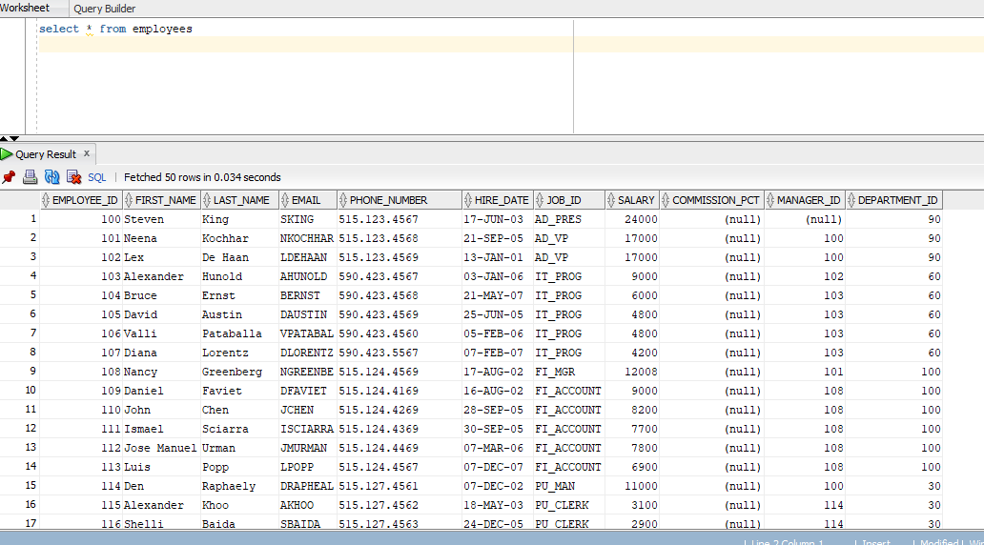

3: Display department_id column, job_id column and first_name of employee table

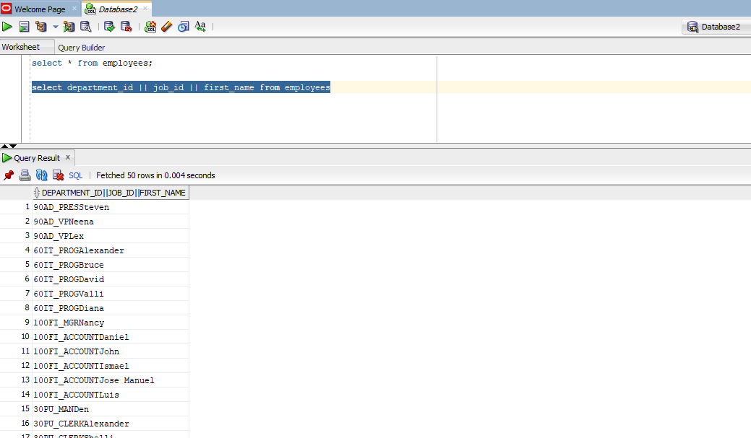

4: Run the arithmetic expression 200+salary*90

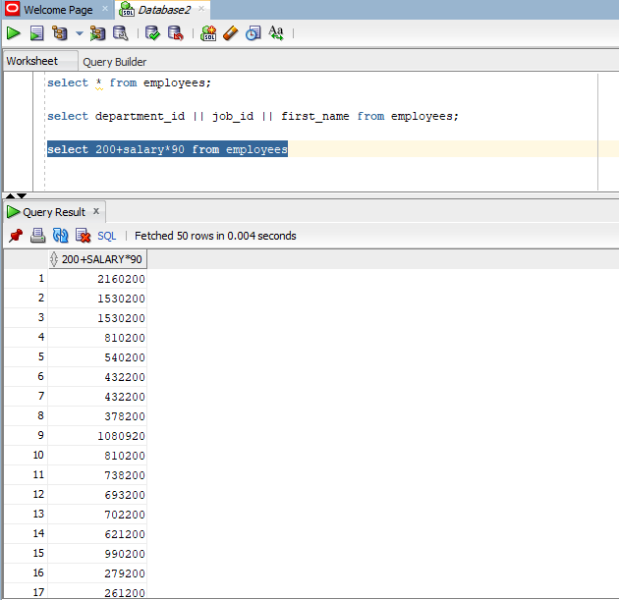

5: Run the arithmetic expression 4/(1000+salary-100)*2

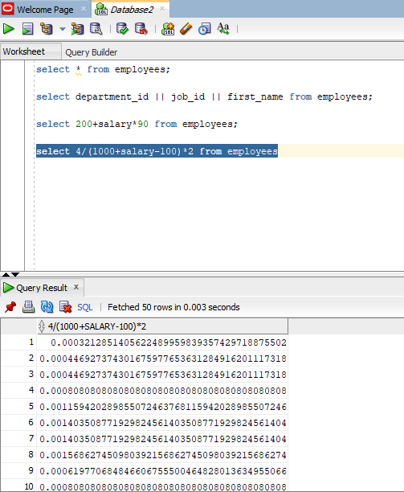

6: Display the name of columns Employees_id, First_name, last_name, department_id as d_id, name,l_name,dept_id respectively

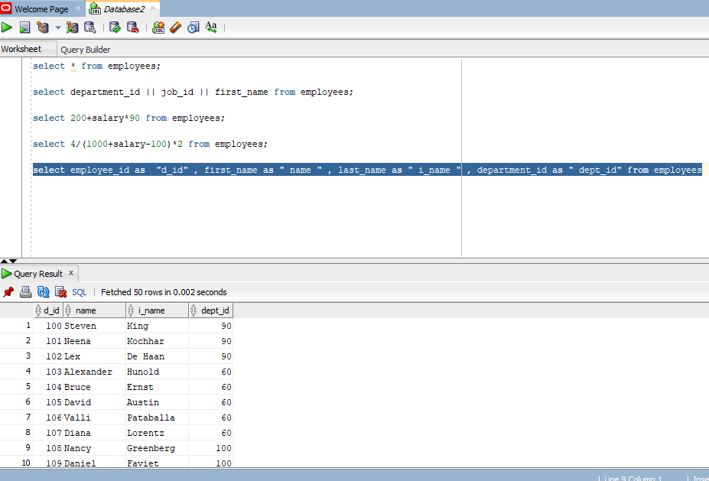

7: Display first_name, salary as monthly_salary and multiply that salary with 12 and show the multiplied salar as annual_salary

